Sprint 3 documentation
Contents
User stories 2
Database design 3
Task breakdown 5
GitHub repo Links 5
GitHub Metrics 7
Kanban board screenshot (project backlog) 8
Meetings Record 8

User stories
ID | User Story | Status
User-Cat1 | As a visitor, I want to browse content by category (Food, Language, Traditions etc.) so I can find topics that interest me. | Complete
User-Cat2 | As a visitor, I want to see how many post exist in each category so I know what topics are the most popular. | Complete
User-Cat3 | As a visitor, I want to be able to browse content by country so I can choose what culture I want to learn. | Complete
User-Cat4 | As a visitor, I want to see popular tags so I can find trending content. | Complete
User-Cat5 | As a visitor, I want to click on a category to view all posts in that category so I can find related content | Complete
User-Usr1 | As a visitor, I want to view a list of all community members | Complete
User-Usr2 | As a visitor, I want to be able to view a user profile | Complete
User-Post1 | As a visitor, I want to browse a list of all posts | Complete
User-Post2 | As a visitor, I want to click on a post to view all details | Complete

Database design
The categories page currently uses sample data for demonstration purposes. The other parts of the app use data pulled straight from the SQL database.
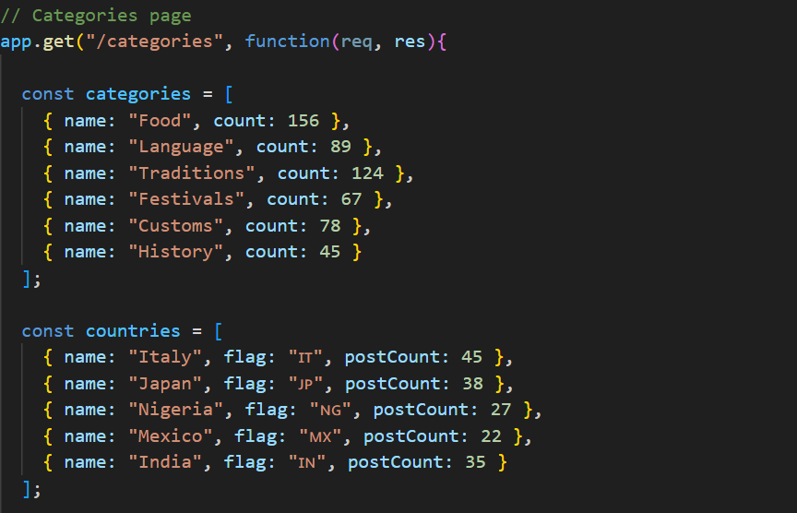
Figure 1: sample data in app.js for the categories page
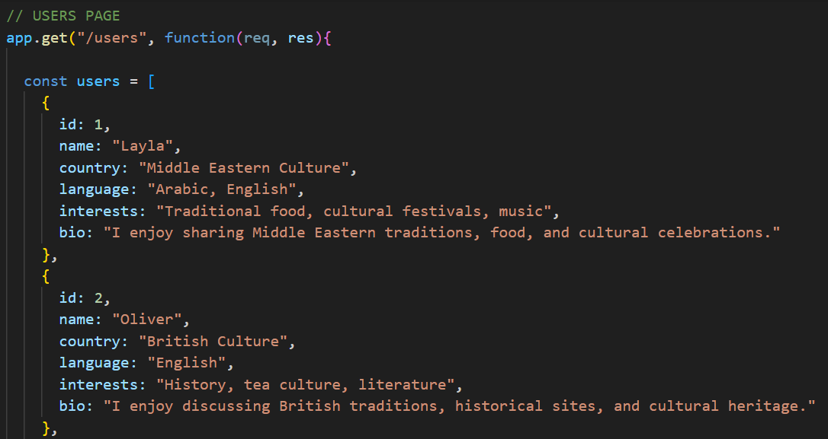
Figure 2: sample data for Users page
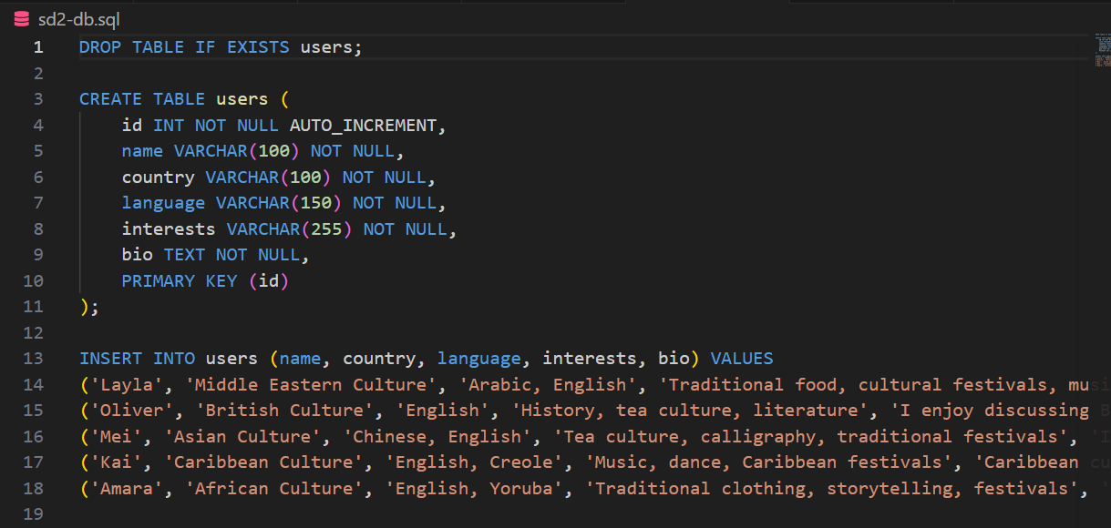
Figure 3: SQL database showing data is pulled from the database rather than sample data being used.

Task breakdown
Task | Description | Status | Member
Categories Page Template | Create Categories page with categories cards | Done | Lucie
CSS Styling | Styles created in styles.css | Done | All
Docker Testing | Verify pages work | Done | All
PDF File | Documentation of all work | Done | Lucie
User List Page | Create user list page | Done | Bahar
User Profile Page | User profile list created | Done | Bahar
Posts List Page | Posts list made | In progress | Aderinola
Post Detail Page | Post details created | In progress | Aderinola
Database Setup | SQL database created with data inputted | Done | All

GitHub repo Links
GitHub repo: https://github.com/Gencyigb/Cultural-connections
Github project board: https://github.com/users/Gencyigb/projects/1/views/1

GitHub Metrics
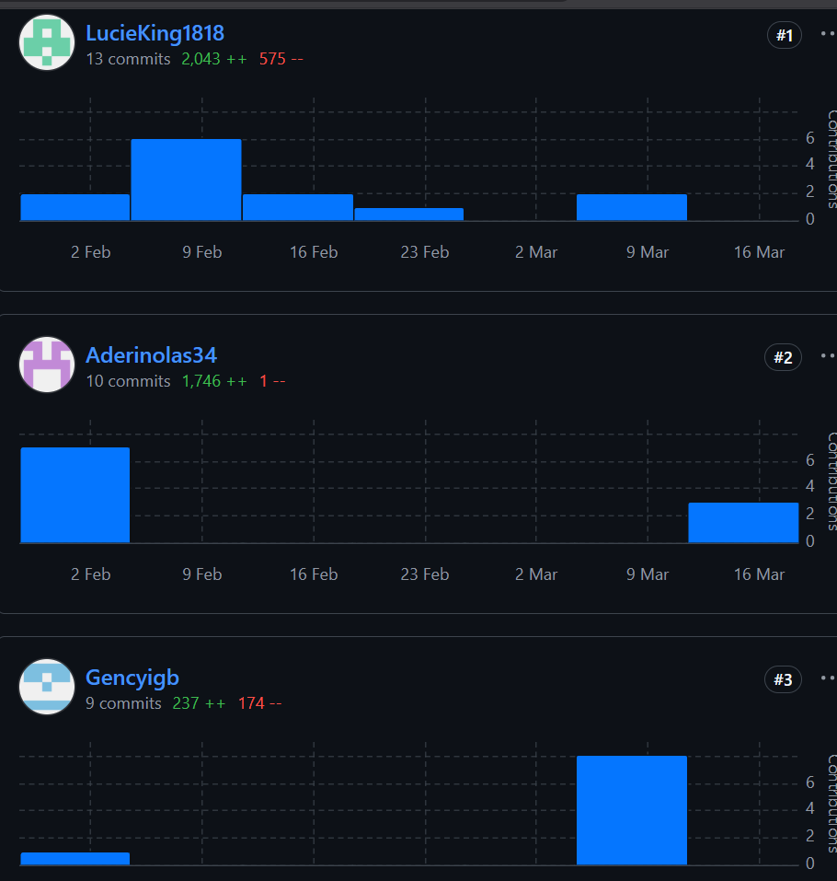

Kanban board screenshot (project backlog)

Meetings Record
Date: 10th march 2026
Attendees: Lucie, Bahar, Aderinola
Assigned work:
- Lucie: Categories page, PDF file documentation
- Bahar: Users page and User Profile Page
- Aderinola: Posts pages
I conducted this meeting via WhatsApp and allocated work to everyone. We used this time to discuss what is expected and that everyone was happy with the potential outcome of this sprint. Any miscommunications were cleared up in a constructive way so everyone understood the assignment.

